

MINI DICTIONARY

Data Structures – CS163

23APCS2 | Group 3



Last Modified Day:

August 22, 2024

Table of Contents

A. Abstract 2

B. Introduction 2

1. Overview: 2

2. Key features: 2

C. Group Information 3

Group ID: 3 3

Member: 3

1. Le Vinh Thuan (Team Leader) – 231250__ (ANY%) 3

2. Tu Cong Thanh – 231250__ (ANY%) 4

3. Le Thi Tuyet Tram – 231250__ (ANY%) 4

4. Nguyen Thu Uyen – 23125048 (ANY%) 4

5. Ngo Hoang Bao Thach – __1250__ (ANY%) 5

D. Data Storage 5

E. Project Architecture 6

F. Implementation Detail 7

G. Technical Problems and Solutions: 8

Back-end: Data Structure 8

UI: Multi-lined table 8

H. Feature Demonstration: 9

I. Conclusion 10

References 10

# Abstract

In this project, we focus on implementing a dictionary application using the programming language C++, Ternary Tree and Binary Tree data structure, Cross-Platform GUI Library wxWidgets and CMake. It is thanks to the help of CS163 course’s lecture notes, ABCDXYZ BOOKS AND PAPER.

The main objective of this project is to use Ternary Tree to develop a user-friendly and responsive mini dictionary application. The primary aim is to demonstrate the use of data structure in making efficient word searches, additions, edits, and deletions, help users look up the meanings of words and allowing users to switch between various types of dictionaries, such as English-to-English, English-to-Vietnamese, and Vietnamese-to-English.

The report outlines the project’s objectives, key features, and the algorithms employed to optimize performance. We have developed and implemented all the functionality required, albeit not able to fully preprocess data and clean code.

# Introduction

## Overview:

The mini dictionary group project is a practical application of the data structures and algorithms learned in the CS163 course. We are required to manage tasks in Trello and source code in Git. Only array and vector are allowed.

Dictionaries are indispensable tools in language learning and communication, and their digital versions offer enhanced accessibility. The project’s motivation stems from the need to create an efficient dictionary application capable of handling large datasets, such as large number of words, slang terms, and emojis.

By implementing this project, the group aims to demonstrate the effective and suitable use of data structures in managing and manipulating large datasets.

## Key features:

* Switch between data sets, including:
  + English-to-English
  + English-to-Vietnamese
  + Vietnamese-to-English
  + Emoticon
  + English slang
* Search:
  + Using keywords
  + Using definitions
* View Search History
* View, add or remove words from Favorite list
* Modifying dictionary entries:
  + Add/Edit/Remove words
  + Reset dictionary
* Additional features:
  + View a random word and its definition.
  + Play Guess the meaning game.
  + Play Guess the word game.

# Group Information

Include the group ID and a list of group members along with their names and roles in the project. It's also important to mention the tasks assigned to each member and their individual contribution percentages.

## Group ID: 3

## Member:

### Le Vinh Thuan (Team Leader) – 231250__ (ANY%)

* Planning meetings and manage coding progress
* Build Ternary Tree structure
* Gathering Data Set
* UI implementation:
  + Home Page
* Feature:
  + Search using keywords.
  + Provide a word with four definitions, and users guess its meaning.
  + Provide a random definition with four keywords, and users choose the correct word.

### Tu Cong Thanh – 231250__ (ANY%)

* Build Ternary Tree structure
* Gathering Data Set
* UI implementation:
  + Base frame
  + Search Page
  + Game Page
* Feature:
  + Switching Data Sets
  + Search with definition
  + Reset dictionary to its original state.

### Le Thi Tuyet Tram – 231250__ (ANY%)

* UI Design:
  + Light Mode
* UI implementation:
  + Game Page
  + More Page
* Feature:
  + Users can add a new word and its definition.
  + Users can edit the definition of an existing word.
  + Users can remove a word from the dictionary.

### Nguyen Thu Uyen – 23125048 (ANY%)

* Documentation:
  + Report
  + README.md
* UI Design:
  + Light Mode (Home Page, Search Page, Dialogs, Add/Edit, Game Page, History and Favorite Page)
  + Dark Mode
* UI Implementation:
  + History Page
  + Favorite Page
* Features:
  + View the history of search words again.
  + Users can view a random word and its definition.
  + Users can view their favorite list.
  + Users can remove/add a word from their favorite list.

### Ngo Hoang Bao Thach – __1250__ (ANY%)

* Features:

# Data Storage

Discuss how data is stored in the project. Explain the rationale behind the chosen data storage approach.

# Project Architecture

Describe the overall architecture of the project, including the meaning and structure of project folders. Explain the main data structures employed in the project and their alternatives, highlighting why certain choices were made.

# Implementation Detail

Provide a list of the structures/classes used in the project and their relevant functions. Choose several main flows or use cases and explain how these structures and methods collaborate with each other to achieve the desired functionality.

# Technical Problems and Solutions:

We encountered some big technical challenges that we must resolve together, include:

## Back-end: Data Structure

* sryetrtu

## UI: Multi-lined table

* Sryetrtu

# Feature Demonstration:

Showcase all the features of the project, either through a video clip or screenshots. Provide a step-by-step explanation of each feature and its functionality.

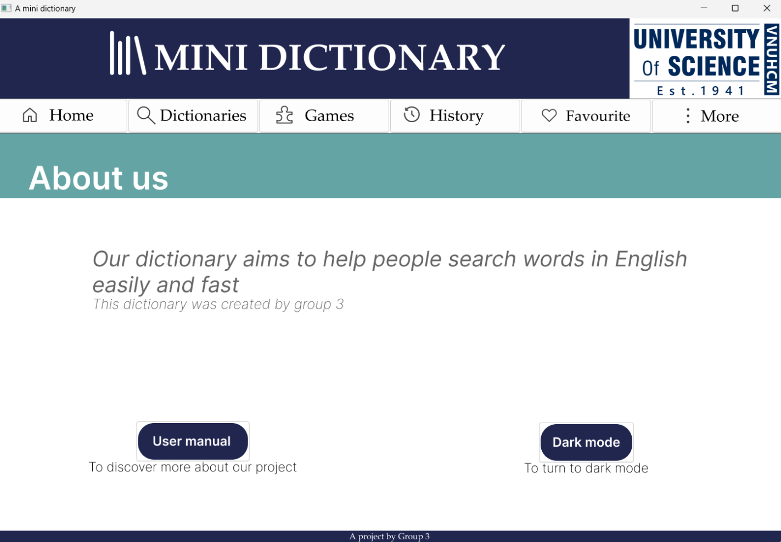

# Conclusion

The mini dictionary project successfully achieved its objectives of creating a functional and efficient dictionary application using C/C++. It was an exciting project to work on, and we gained a lot from it, above and beyond its original scope. We were able to study and research many different topics outside of our class.

Although the application is far from perfect, it works as we desired. The mini dictionary showcases the group's proficiency in data structures handling, and all the core and additional functionalities work successfully. While the project has met its initial goals, we believe there are a lot of potential enhancements for this application in the future, including but not limited to transforming the data sets into one unify format that is more easily and effectively processed, and STH STH.

# References

[1] wxWidgets User Manuals <https://docs.wxwidgets.org/3.2/>

[2] Ternary Tree https://docs.wxwidgets.org/3.2/

[3] Data Sets User Manuals <https://docs.wxwidgets.org/3.2/>

[4] Figma User Manual User Manuals https://docs.wxwidgets.org/3.2/